**TEST REPORT – 14.10.2023** [**https://www.pothys.com/**](https://www.pothys.com/)

**Retested & Closed Issues:**

1, Decimal part getting cut in quantity box of fabric material products in both product and cart page in desktop UI.

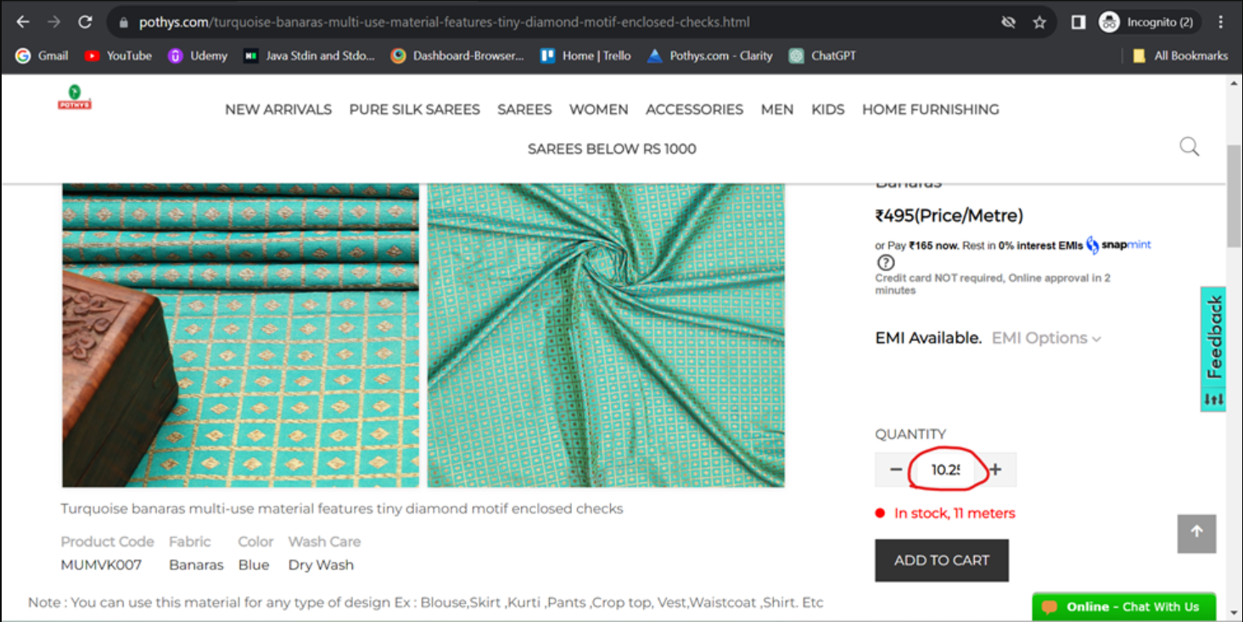

**Fixed:**

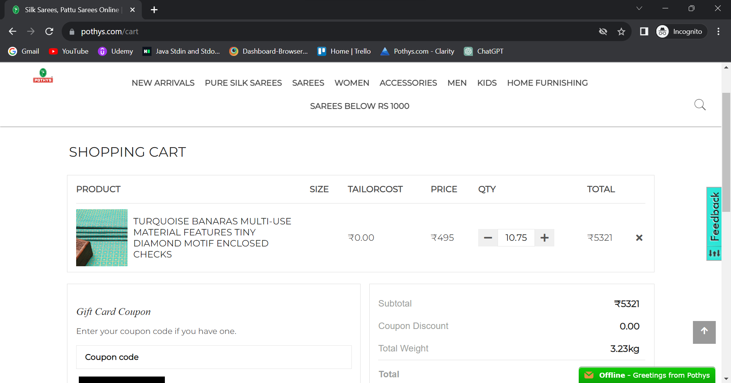

2, If an additional option like saree falls only customer needed it is not possible to move forward without selecting the tailoring measurements. It is mandating the customer to select the measurements.

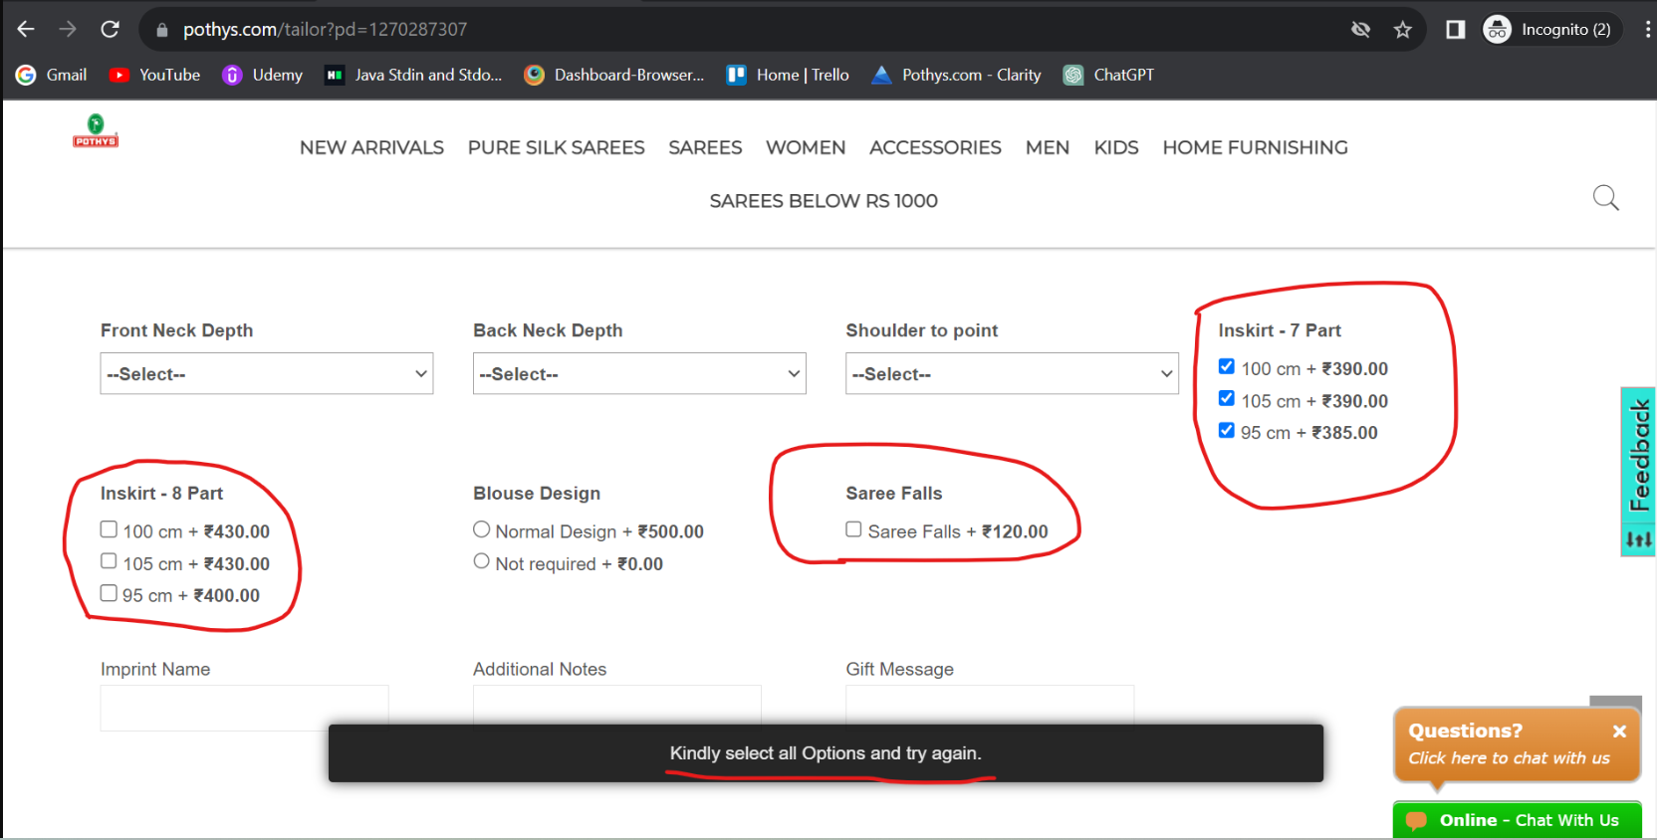

**Fixed:**

